WEFESite Analyst Report: Delmas Farm Case Study

WEFESiteAnalyst is an automatized remote data collection tool for the site-tailored planning of integrated Water-Energy-Food-Environment Systems (iWEFEs). This report presents findings and insights from the analysis of the case study for Delmas Farm. The WEFESite Analyst tool aims to provide valuable information for decision-making and planning related to environmental factors, site suitability, and more. Thank you for using WEFESite Analyst for your case study analysis!

# Satellite Map

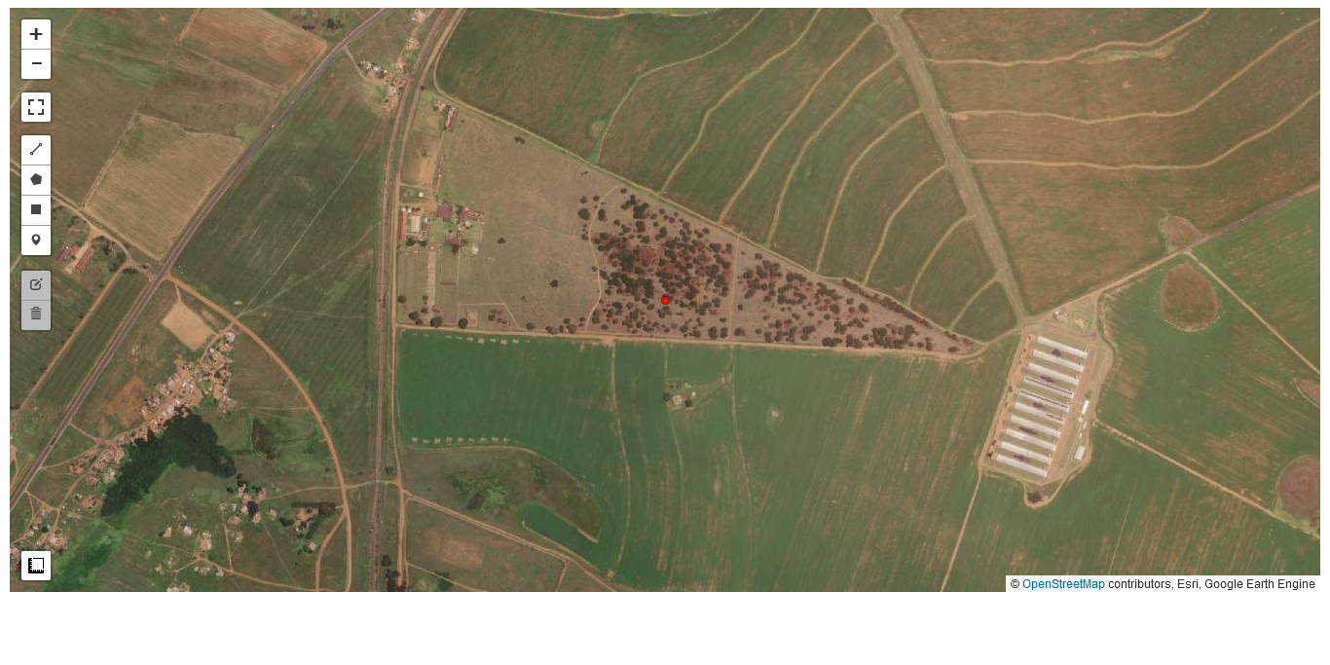

# Terrain

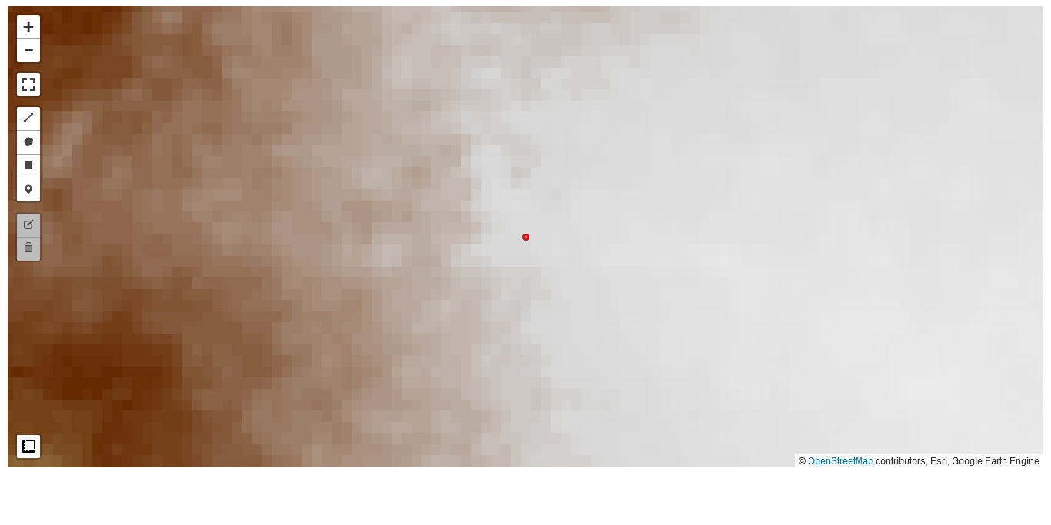

**Elevation value at location:** 1590 meters

# Landuse

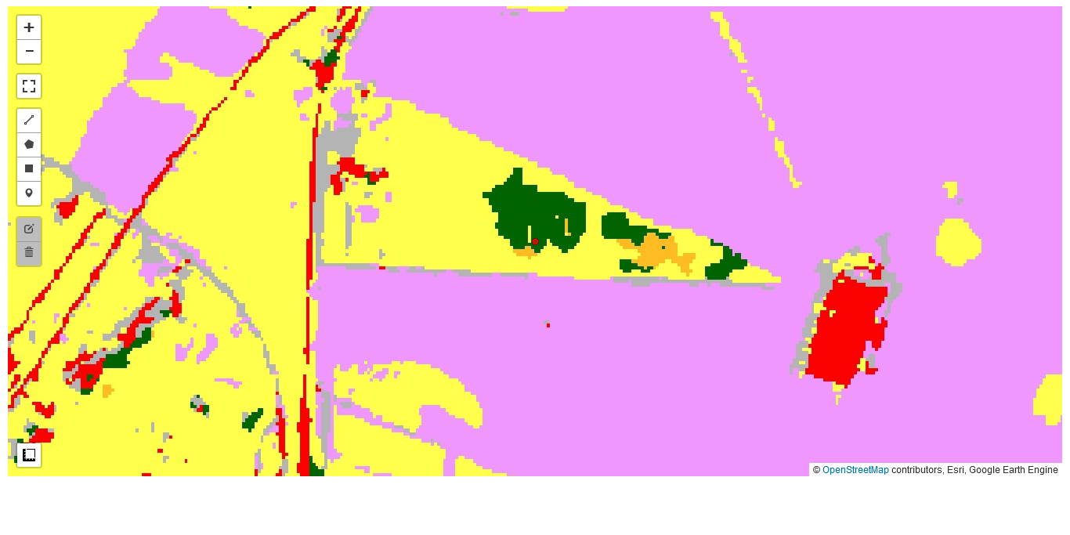

# Hydrology

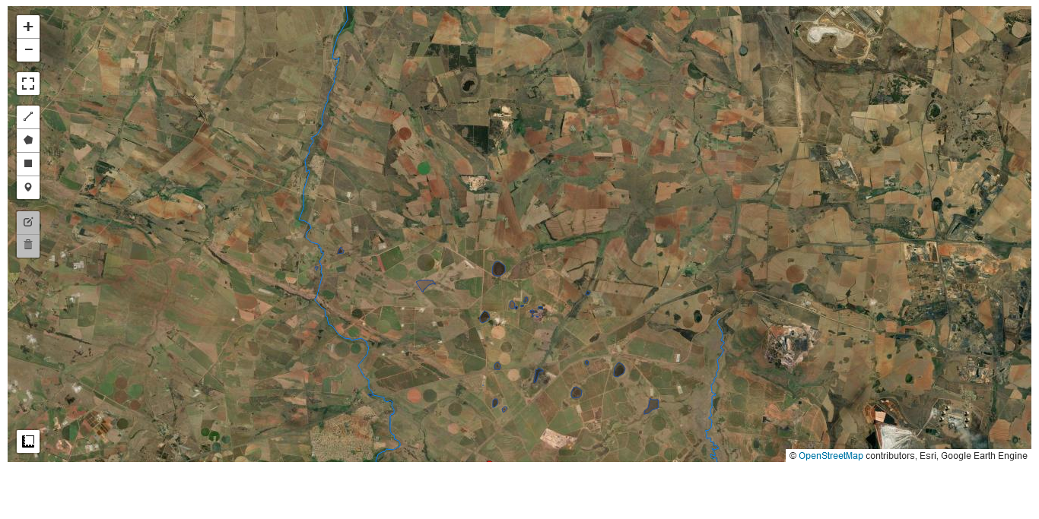

# Soil

|  |  |
| --- | --- |
| Parameter | Value |
| soil organic carbon [dg/kg] | 171.00 |
| bulk density [cg/cm³] | 141.00 |
| cation exchange capacity at pH 7 [mmol(c)/kg] | 208.00 |
| nitrogen content [cg/kg] | 1767.00 |

# Climate

## Solar Irradiance

**Total solar irradiance:** 1986.58 kWh/m^2/a

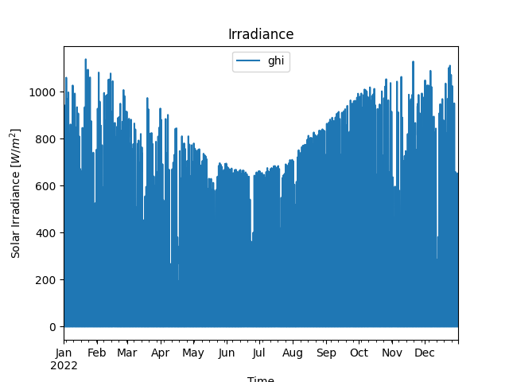

## Windspeed

**Average windspeed:** 2.89 m/s

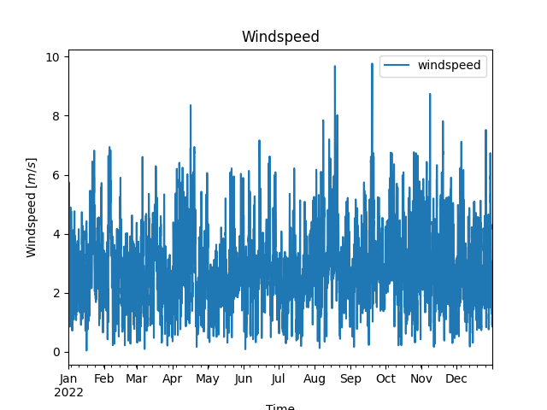

## Precipitation

**Total precipitation:** 848.73 mm

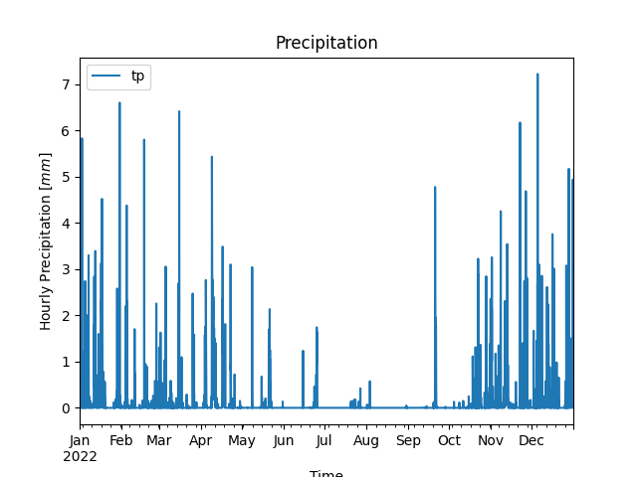

## Temperature

**Average temperature:** 16.86 °C

